
Security Assessment
CONFIDENTIALITY NOTE: The information contained in this report document is for the exclusive use of the client specified above and may contain confidential, privileged and non-disclosable information. If the recipient of this report is not the client or addressee, such recipient is strictly prohibited from reading, photocopying, distributing or otherwise using this report or its contents in any way.

Login Failures by Computer
Prepared for:
Customer

Prepared by:
All Information Services, Inc

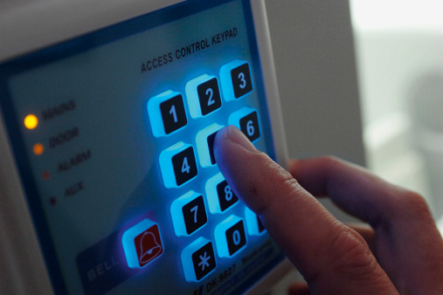

Table of Contents

1 - Domain: Corp.MyCo.com
1.1 - DC01
1.2 - DC02
1.3 - DEVTFS
1.4 - FILE2012-1
1.5 - HV01
1.6 - HV02
1.7 - HV03
1.8 - HV04
1.9 - HV05
1.10 - MYCO30DEV
1.11 - MYCOROOTAUTH
1.12 - SHAREPOINT-01
1.13 - SQL2012-01
1.14 - STORAGE01

1 - Domain: Corp.MyCo.com

1.1 - DC01

Operating System | Windows Server 2012 Standard
DNS Name(s) | dc01.corp.myco.com, corp.myco.com
IP Address(es) | fe80::c479:f74:16d0:1a95%16,172.20.1.3,10.0.1.3

Network Logon Failures (logon for remote access to a system resource, such as a shared folder)

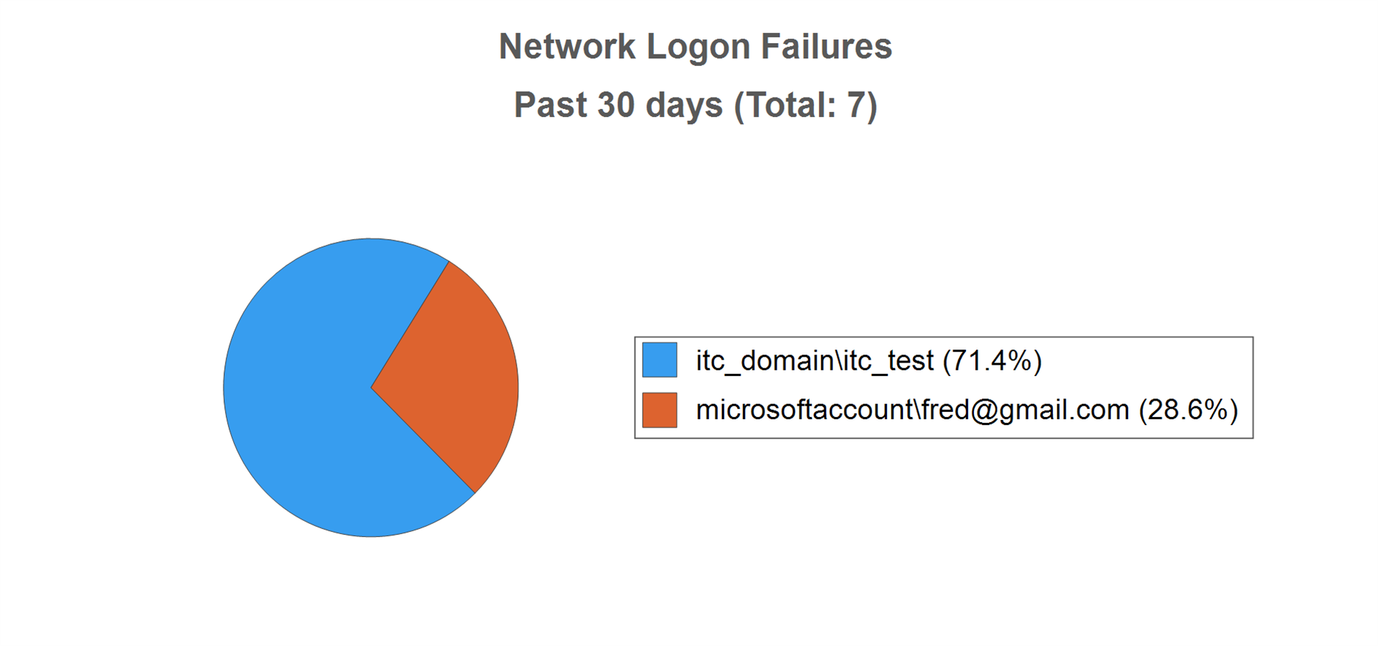
 | User | Failures
 | User | Past 24 hours | Past 7 days | Past 30 days
 | Top Five
 | itc_domain\itc_test | 5 | 5 | 5
 | MicrosoftAccount\Fred@gmail.com | 2 | 2 | 2

1.2 - DC02

Operating System | Windows Server 2012 R2 Datacenter
DNS Name(s) | dc02.corp.myco.com, corp.myco.com
IP Address(es) | 172.20.0.4,10.0.1.4

Network Logon Failures (logon for remote access to a system resource, such as a shared folder)

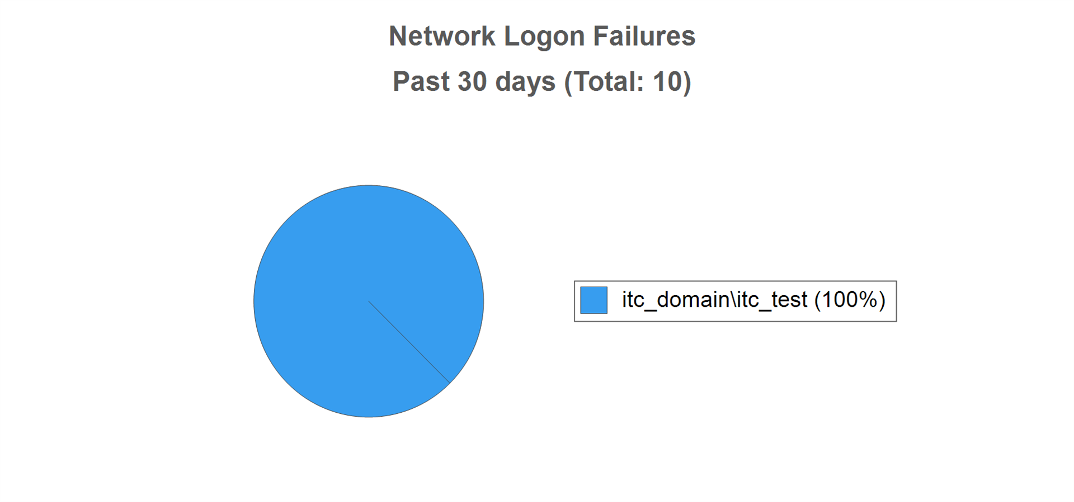
 | User | Failures
 | User | Past 24 hours | Past 7 days | Past 30 days
 | Top Five
 | itc_domain\itc_test | 9 | 10 | 10

1.3 - DEVTFS

Operating System | Windows Server 2012 Standard
DNS Name(s) | devtfs.corp.myco.com
IP Address(es) | 10.0.7.69

Network Logon Failures (logon for remote access to a system resource, such as a shared folder)

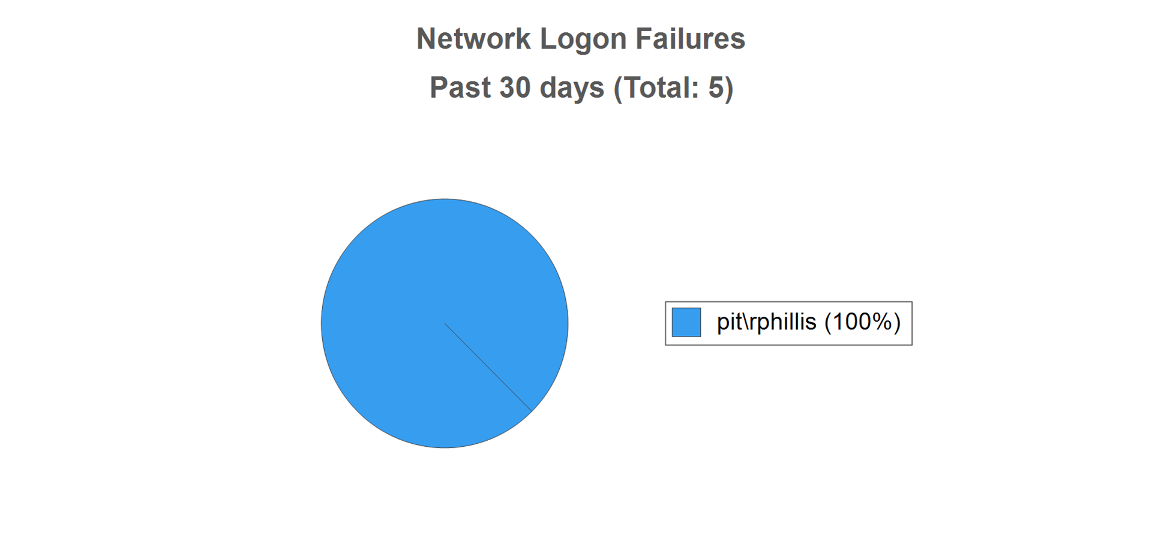
 | User | Failures
 | User | Past 24 hours | Past 7 days | Past 30 days
 | Top Five
 | PIT\rphillis | 0 | 5 | 5

1.4 - FILE2012-1

Operating System | Windows Server 2012 R2 Standard
DNS Name(s) | file2012-1.corp.myco.com, store2012-1.corp.myco.com
IP Address(es) | 10.0.1.41

Network Logon Failures (logon for remote access to a system resource, such as a shared folder)

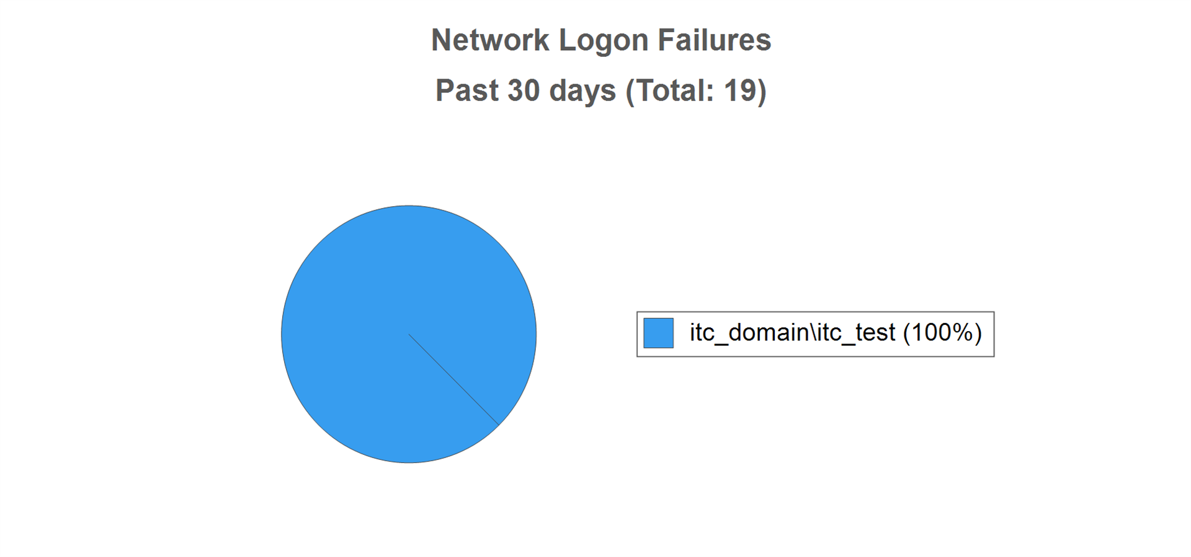
 | User | Failures
 | User | Past 24 hours | Past 7 days | Past 30 days
 | Top Five
 | itc_domain\itc_test | 9 | 19 | 19

1.5 - HV01

Operating System | Windows Server 2012 R2 Standard
DNS Name(s) | hv01.corp.myco.com
IP Address(es) | 10.0.1.111

Network Logon Failures (logon for remote access to a system resource, such as a shared folder)

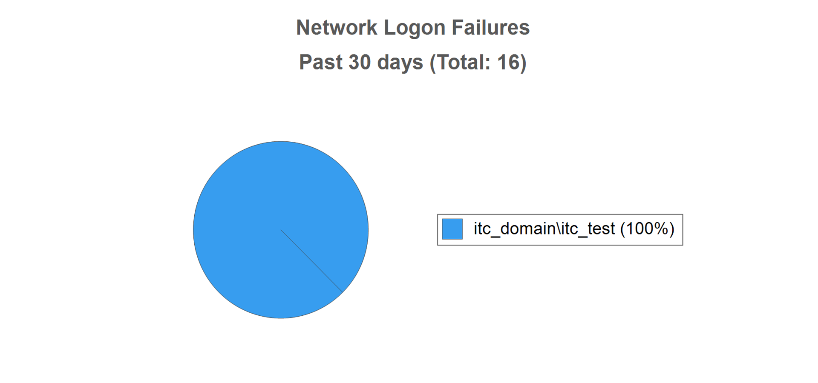
 | User | Failures
 | User | Past 24 hours | Past 7 days | Past 30 days
 | Top Five
 | itc_domain\itc_test | 9 | 16 | 16

1.6 - HV02

Operating System | Windows Server 2012 R2 Standard
DNS Name(s) | hv02.corp.myco.com, corp.myco.com
IP Address(es) | 10.0.7.27

Network Logon Failures (logon for remote access to a system resource, such as a shared folder)

 | User | Failures
 | User | Past 24 hours | Past 7 days | Past 30 days
 | Top Five
 | itc_domain\itc_test | 9 | 19 | 19

1.7 - HV03

Operating System | Windows Server 2012 Standard
DNS Name(s) | hv03.corp.myco.com
IP Address(es) | 10.0.1.139,10.0.1.131,10.0.1.135,10.0.1.132

Network Logon Failures (logon for remote access to a system resource, such as a shared folder)

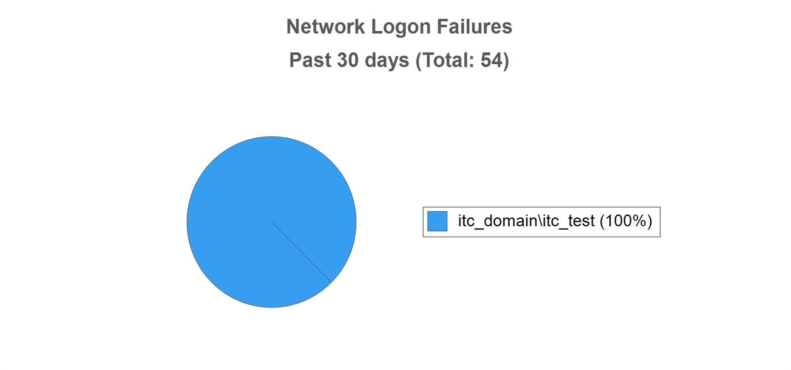
 | User | Failures
 | User | Past 24 hours | Past 7 days | Past 30 days
 | Top Five
 | itc_domain\itc_test | 54 | 54 | 54

1.8 - HV04

Operating System | Windows Server 2012 Standard
DNS Name(s) | hv04.corp.myco.com
IP Address(es) | 10.0.1.141,10.0.1.149,10.0.1.142,10.0.1.145

Network Logon Failures (logon for remote access to a system resource, such as a shared folder)

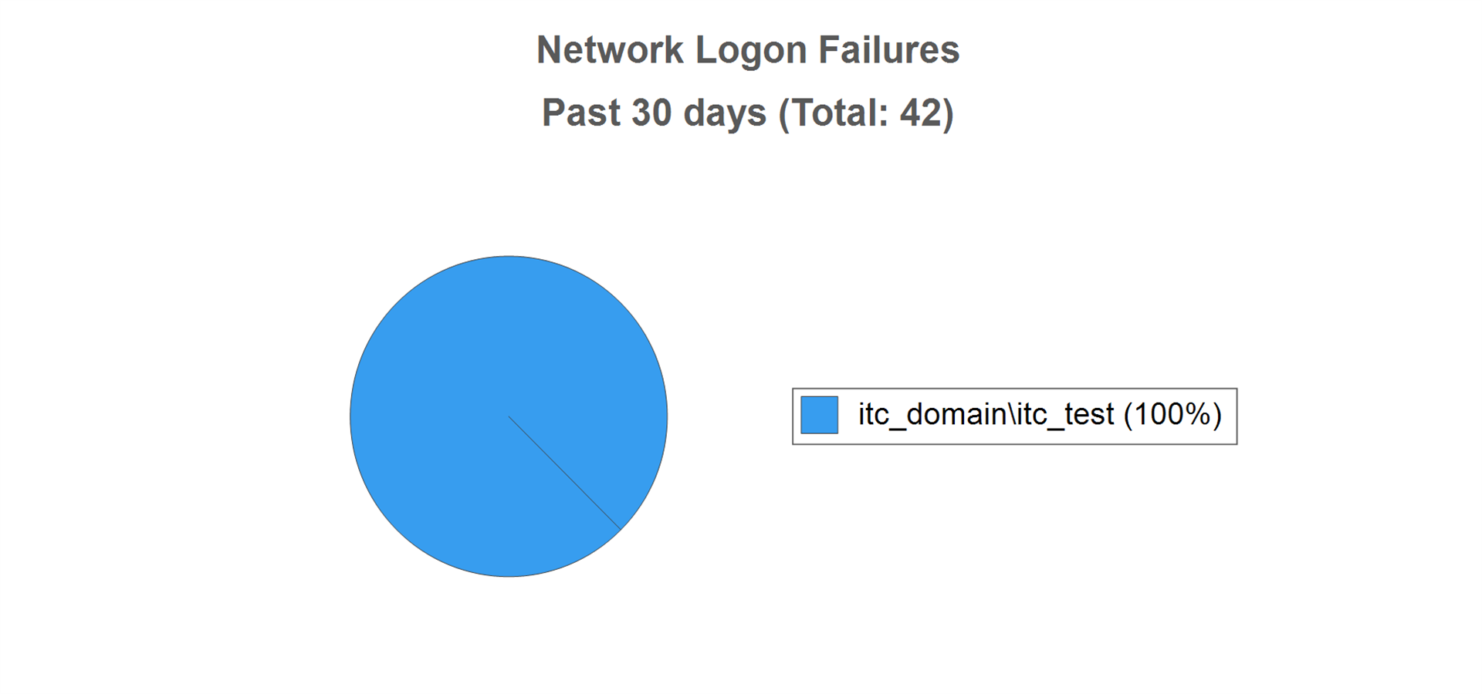
 | User | Failures
 | User | Past 24 hours | Past 7 days | Past 30 days
 | Top Five
 | itc_domain\itc_test | 42 | 42 | 42

1.9 - HV05

Operating System | Windows Server 2012 R2 Standard
DNS Name(s) | hv05.corp.myco.com, mycodemo.corp.myco.com
IP Address(es) | 10.0.7.61

Network Logon Failures (logon for remote access to a system resource, such as a shared folder)

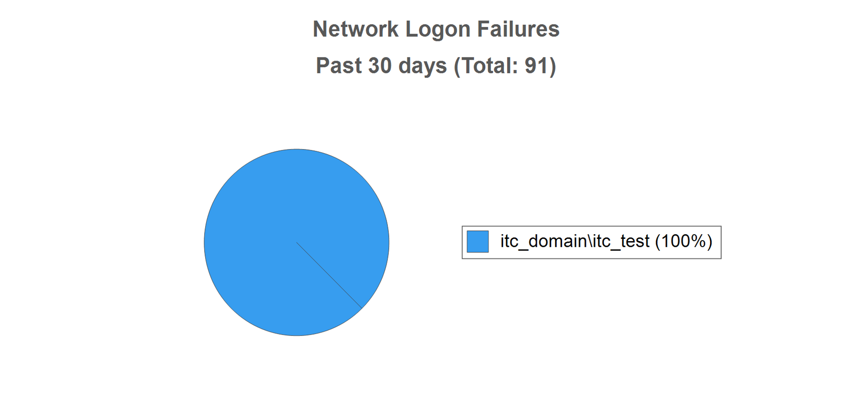
 | User | Failures
 | User | Past 24 hours | Past 7 days | Past 30 days
 | Top Five
 | itc_domain\itc_test | 9 | 37 | 91

1.10 - MYCO30DEV

Operating System | Windows 2000 Server
DNS Name(s) | myco30dev.corp.myco.com
IP Address(es) | 10.0.7.65

Interactive Logon Failures (logon at keyboard and screen of system)

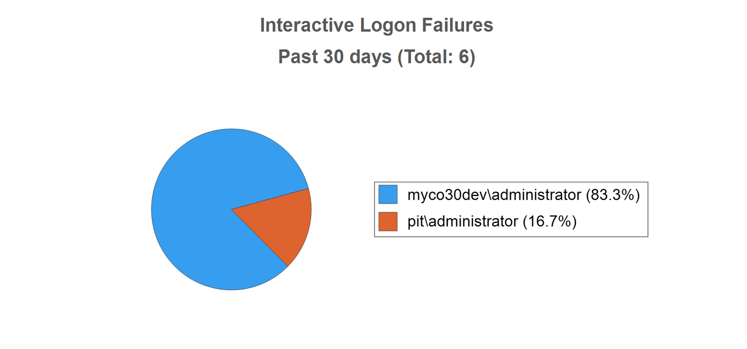
 | User | Failures
 | User | Past 24 hours | Past 7 days | Past 30 days
 | Top Five
 | MYCO30DEV\administrator | 2 | 5 | 5
 | PIT\Administrator | 0 | 1 | 1

1.11 - MYCOROOTAUTH

Operating System | Windows Server 2012 R2 Datacenter
DNS Name(s) | mycorootauth.corp.myco.com
IP Address(es) | 10.0.1.44

Network Logon Failures (logon for remote access to a system resource, such as a shared folder)

 | User | Failures
 | User | Past 24 hours | Past 7 days | Past 30 days
 | Top Five
 | itc_domain\itc_test | 9 | 37 | 91

1.12 - SHAREPOINT-01

Operating System | Windows Server 2012 Datacenter
DNS Name(s) | sharepoint-01.corp.myco.com
IP Address(es) | 10.0.1.71

Network Logon Failures (logon for remote access to a system resource, such as a shared folder)

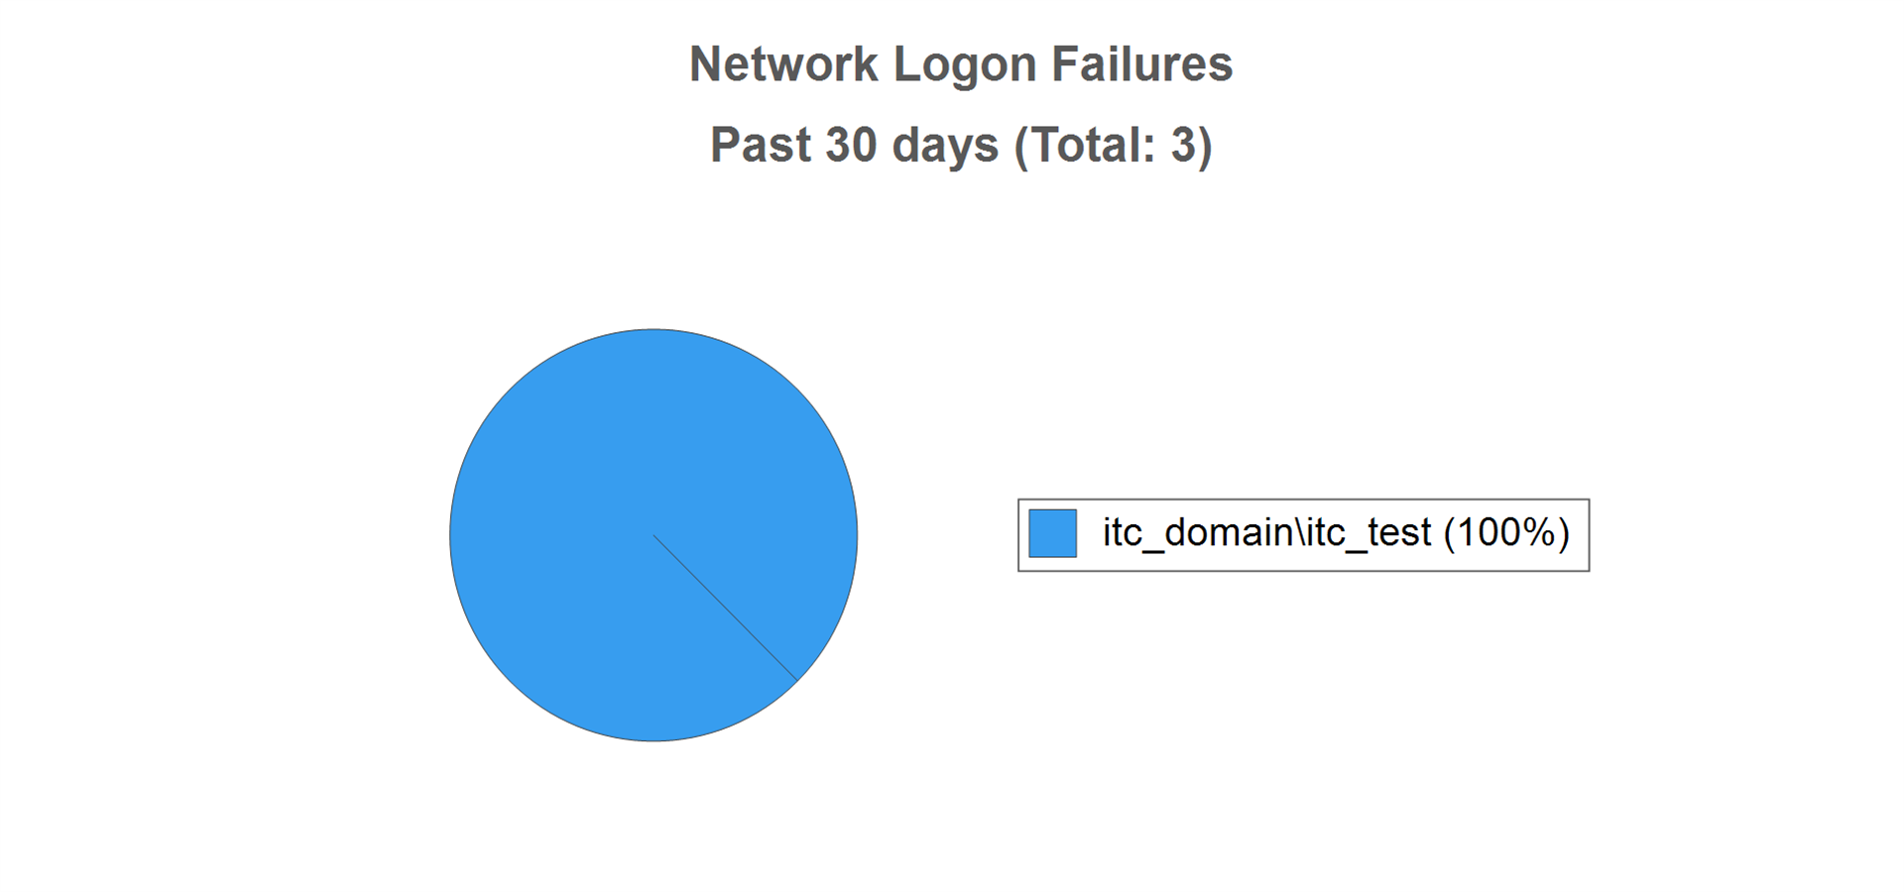
 | User | Failures
 | User | Past 24 hours | Past 7 days | Past 30 days
 | Top Five
 | itc_domain\itc_test | 3 | 3 | 3

1.13 - SQL2012-01

Operating System | Windows Server 2012 R2 Datacenter
DNS Name(s) | sql2012-01.corp.myco.com
IP Address(es) | 10.0.1.61

Network Logon Failures (logon for remote access to a system resource, such as a shared folder)

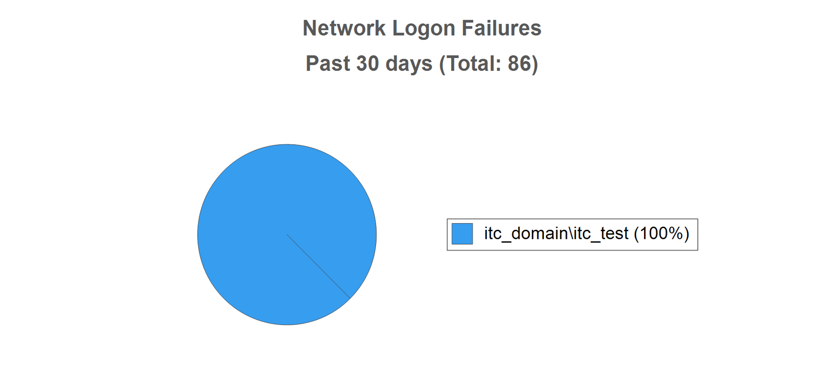
 | User | Failures
 | User | Past 24 hours | Past 7 days | Past 30 days
 | Top Five
 | itc_domain\itc_test | 9 | 37 | 86

1.14 - STORAGE01

Operating System | Windows Server 2008 R2 Enterprise
DNS Name(s) | storage01.corp.myco.com
IP Address(es) | 10.0.1.69

Network Logon Failures (logon for remote access to a system resource, such as a shared folder)

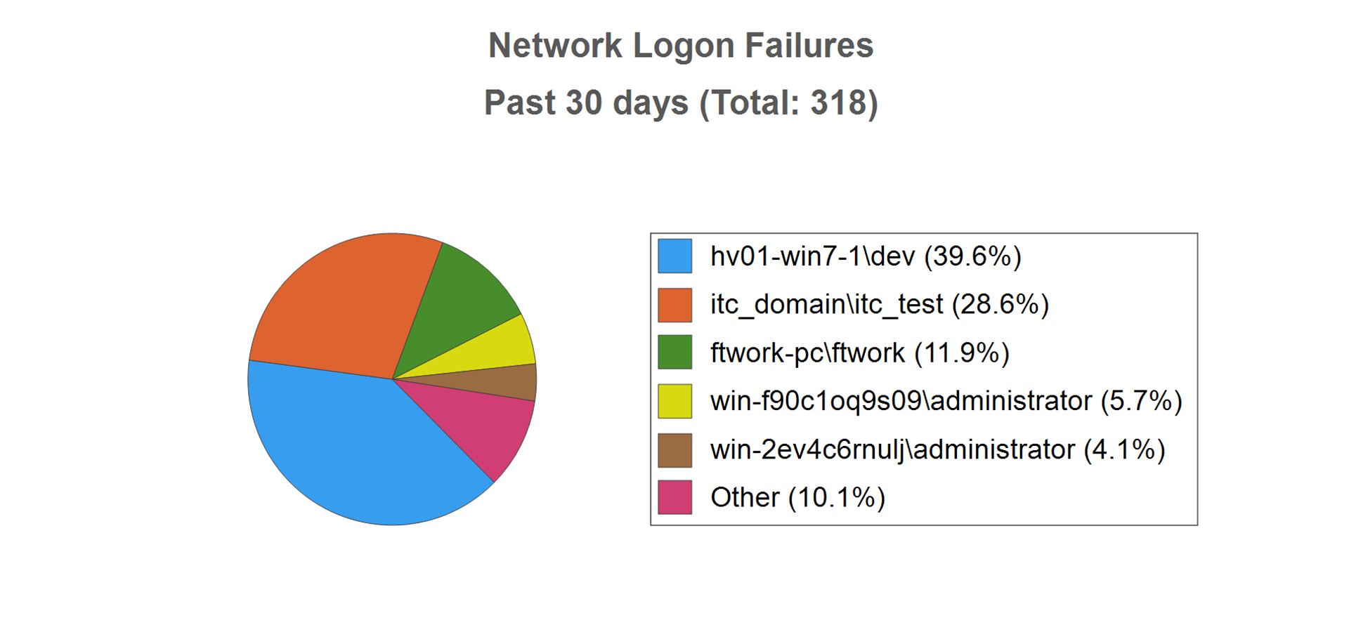
 | User | Failures
 | User | Past 24 hours | Past 7 days | Past 30 days
 | Top Five
 | HV01-WIN7-1\dev | 126 | 126 | 126
 | itc_domain\itc_test | 9 | 37 | 91
 | FTWork-PC\FTWork | 0 | 16 | 38
 | WIN-F90C1OQ9S09\Administrator | 0 | 0 | 18
 | WIN-2EV4C6RNULJ\Administrator | 0 | 0 | 13
 | Other
 | STORAGE01\Guest | 0 | 0 | 11
 | VistaUltimate\admin | 0 | 1 | 7
 | pit\gHAMMOND | 0 | 1 | 6
 | PIT\echristy | 0 | 0 | 5
 | MicrosoftAccount\Fred@gmail.com | 0 | 3 | 3

